**Final Year Project Report**

**Project Name**



**Project Advisor:**

**Submitted By:**

**Session**

**University of Management and Technology**

**C-II Johar Town Lahore Pakistan**

**Dedication**

## 

**Final Approval**

* **Head of Department**  ______________________

Department of Informatics & Systems

School of Systems & Technology

UMT Lahore

* **Director (Final Year Projects-CS)** ______________________

Department of Computer Science.

School of Systems & Technology

UMT Lahore

* **Supervisor** ______________________
* Department of Informatics & Systems.
* School of Systems & Technology

UMT Lahore

* **Co-Supervisor** ______________________

**Acknowledgment**

**Project Title**

**Objective**

**Undertaken by**

**Supervised by**

**Starting Date**

**Completion Date**

**Tools Used**

**Operating System**

**Documentation**

**Plagairism ReportAbstract**

Revision Chart

This chart contains a history of this document’s revisions. The entries below are provided solely for illustration purposes. Those entries should be deleted until the revision/s they refer to have actually been created.

The document itself should be stored in revision control, and a brief description of each version should be entered in the Revision Control System. A brief description can be repeated in this section. Revisions need not be described elsewhere in the document, unless they explain the document.

| Version | Primary Author(s) | Description of Version | Date Completed |
| --- | --- | --- | --- |
| *Draft* | TBD | Initial draft created for distribution and review comments | (To be decided) TBD |
| *Preliminary* | TBD | Second draft incorporating initial review comments, distributed for final review | TBD |
| *Final* | TBD | First complete draft, which is placed under change control | TBD |
| *Revision 1* | TBD | Revised draft, revised according to the change control process and maintained under change control | TBD |
| *Revision 2* | TBD | Revised draft, revised according to the change control process and maintained under change control | TBD |
| *Etc.* | TBD | TBD | TBD |

# Contents

*New paragraphs formatted as Heading 1, Heading 2, and Heading 3 will be added to the table automatically. To update this table of contents in Microsoft Word, put the cursor anywhere in the table and press F9. If you want the table to be easy to maintain, do not change it manually.*

Contents 1

Definitions and Acronyms 3

List of Figures 4

List of Tables 5

1. Introduction 6

1.1 Motivations 6

1.2 Project Overview 6

1.3 Problem Statement 6

1.4 Objectives 6

2. Domain Analysis 7

2.1 Customer 7

2.2 Stakeholders 7

2.3 Affected Groups with social or economic impact 7

2.4 Dependencies/ External Systems 7

2.5 Reference Documents 7

2.5.1 Related Projects 7

2.5.2 Feature Comparison 8

3. Requirements analysis 9

3.1 Requirements 9

3.2 List of Actors 10

3.3 List of use cases 10

3.4 System use case diagram 10

3.5 Extended use cases 10

3.6 User interfaces (mock screens) 12

4. Data flow diagram (optional) 13

4.1 Data Flow Diagram Level 0 13

4.2 Data Flow Diagram Level 1 13

4.3 Data Flow Diagram Level 2 13

5. System Design 15

5.1 System Architecture Diagram 15

5.2 Class Diagram 16

5.3 Collaboration Diagrams 17

5.4 Other UMLs 18

5.5 ERD 18

5.6 Data Dictionary 18

6. Implementation details 19

6.1 Development Setup 19

6.2 Deployment setup 19

6.3 Algorithms 19

6.4 Constraints 19

6.4.1 Assumptions 19

6.4.2 System constraints 19

6.4.3 Restrictions 19

6.4.4 Limitations 19

7. Testing 20

7.1 Extended Test Cases 20

7.2 Decision Table 20

7.2.1 Code snippet 20

7.2.2 Decision coverage table 20

7.3 Traceability Matrix 21

7.3.1 RID vs UCID (requirements vs use cases) 21

7.3.2 Prototypes (RID vs PID) 22

7.3.3 Test Cases (RID vs TID) 22

7.3.4 Coverage (UCID vs TID) 22

8. Results/Output/Statistics 23

8.1 %completion 23

8.2 %accuracy 23

8.3 %correctness 23

9. Conclusion 24

10. Future work 25

11. Bibliography 26

11.1 Books 26

11.2 Journals 26

11.3 Articles 26

11.4 Research papers 26

11.5 Other References 26

12. Appendix 27

12.1 Glossary of terms 27

12.2 Pre-requisites 27

## Definitions and Acronyms

*Provide definitions or references to all the definitions of the special terms and acronyms used within this document*

e.g

|  |  |
| --- | --- |
| **Acronym** | **Definition** |
| UMT | University of Management and Technology |
| POS | Point of Sale |

Table 1: table of acronyms and definitions

## List of Figures

New figures that are given captions will be added to the table automatically.

* **Insert caption:**
  1. select picture
  2. right click
  3. select “insert caption”
  4. under “options”, choose label as “figure”
  5. Under “caption”, an automatic insertion of “figure no” will appear. Give your figure an appropriate caption
* **Update list of figures:**To update this list in Microsoft Word, put the cursor anywhere in the table and press F9.
* **Note:**  If you want the table to be easy to maintain, do not change it manually.

Figure 1: sample use case diagram with explanation 10

Figure 2: System Architecture 15

## List of Tables

New Tables that are given captions will be added to the table automatically.

* **Insert caption:**
  1. select picture
  2. right click
  3. select “insert caption”
  4. under “options”, choose label as “table”
  5. Under “caption”, an automatic insertion of “table no” will appear. Give your table an appropriate caption
* **Update table:** To update this table of contents in Microsoft Word, put the cursor anywhere in the table and press F9.
* **Note:**  If you want the table to be easy to maintain, do not change it manually.

Table 1: table of acronyms and definitions 3

Table 2: list of stakeholders 7

# Introduction

*This section should describe the project and the software product being to be built. No text is necessary between the heading above and the heading below unless otherwise desired.*

## Motivations

This section deals with the motivation behind choosing this project.

## Project Overview

Give a short summary of the project objective and the system to be developed.

Following are the sample artifacts for this section:

* Problems or Overview Statement
* Customer
* Goals
* System functions
* System attributes

## Problem Statement

This section should describe the need for this projectand the problem this project is addressing.

The problem statement should be brief, comprising of not more than 150 words

## Objectives

What objectives (outcomes) do you expect to achieve on the completion of this project. e.g.

* Give precise allocation of class rooms
* Generate an image analysis system for suspect identification
* Analysis of data for fraud detection
* …

# Domain Analysis

## Customer

A brief description of the client with whom you are working (or the potential customers). The organization, its products/services etc.**You will fill this section only if you have a client (contracted) .**

## Stakeholders

List of all stakeholders along with their roles in making of the system e.g

|  |  |
| --- | --- |
| **Stakeholder** | **Role in System** |
| Class coordinator | He is responsible for allocating classrooms for different department. In case of clash/missed classes, he is responsible for entering the details in the system. At the end of the week, he can request the system to generate appropriate reports on no. of clashes reported or missed classes. |

Table 2: list of stakeholders

## Affected Groups with social or economic impact

Those impacted by the deployment of the system. This can be a simple list as well as a bulleted one with short explanations.**Link them with your objectives**

e.g.

* Sales staff

There will be reduced paper work for them. Also they will be able to provide better customer care as system will help them respond to queries quickly.

This may include users as well as support groups

## Dependencies/ External Systems

Systems and/ or products, this project depends upon for its completion.

e.g.

* Cyber Cash

## Reference Documents

Provide references to all documents that have been consulted during the analysis phase.

### Related Projects

List of all the documents/ projects that you have looked up as reference material for this project along with their links/references. E.g

In order to develop UMTmanagementSystem, we looked up several similar systems. Their details are given below

1. FastManagementSystem(FMS)

Developed by XYZ. The partial documentation was obtained by the XYZ development team and the working of this management software was observed from abcFAST.com.pk

1. BeaconHouse Management System (BHMS)

Developed by ABC. the working of this management software was observed from abcbeaconhouse.com.pk. no relevant documentation was available.

1. “constructing and ideal academic system” (CIAS)

Research paper published by IEEE. The research paper is not available for free. It is only available to IEEE members

### Feature Comparison

|  |  |  |  |  |  |
| --- | --- | --- | --- | --- | --- |
| Sr No. | Comparison Feature | FMS | BHMS | CIAS | remarks |
| 1 | ABC | FMS covers the feature ABC completely as desired | BHMS does not support feature ABC | CIAS suggests that maximum efficiency can be achieved if ABC is implemented using algorithm abc. | Using the ABC feature from FMS and improving it with abc algorithm can provide maximum efficiency |

# Requirements analysis

## Requirements

*This section is can be skipped, if Requirement Specifications document has been developed for the project. Otherwise this section is mandatory.*

*This section may contain*

*End user, operator, support, or integration functions,*

*Performance requirements,*

*Design constraints,*

*Programming language, and*

*Interface requirements.*

*System functions are descriptions of what a system is supposed to do. They should be identified and listed in logical cohesive groups, with their category (priority) assigned. These system functions will be identified as a result of the requirement gathering process conducted with the client. However, in some cases, prior to the development of the Functional Specifications the requirements may already have been listed in a document: if this is so then a reference to the document may suffice.*

*To verify that some* ***X*** *is indeed a system function; it should make sense in the following sentence:*

*The system should do <****X****>*

*The table below gives an example of how system functions can be listed:*

*The Functions column gives a brief one-line description of the required functionality.*

*The Category column refers to the status of the functionality for the proposed system. The options for the Category are defined below.*

*The Attribute column defines the system characteristics. The Details and Constraints column specifies the conditions within which the attribute is applicable. Section 1.12 defines the default Attributes and the related Constraints. In case, the default conditions are to be over-ridden then the conditions can be defined in this table.*

*Function Categories*

|  |  |
| --- | --- |
| ***Functional Requirements*** | ***The services requested by the user*** |
| *Non-Functional Requirements* | *The supporting requirements for functional requirements. Theses include the* ***measureable*** *quality attribute.* |
| *Data Requirements* | *How your data will be stored* |
| *Constraints* | *by the client On your system* |
| *External interface requirements* | *How will your system connect to other software/components* |

|  |  |  |  |  |
| --- | --- | --- | --- | --- |
| *RID* | *description* | *Category* | *Attribute* | *Details & Boundary Constraints* |
| *R1.1* | *Record the underway sale – the items purchased* | *non-functional* | *System Response time* | *Price listing within 3 seconds*  *Availability agreement in less than 10 sec* |
| *R1.2* | *Reduce inventory quantities when a sale is committed* | *non-functional* | *Concurrent user load* |  |

## List of Actors

Define the system boundary and list all actors with the use cases.**all the actors must also be mentioned in your list of stakeholders**

For example:

Cashier; this person performs all the financial activities

Account Manager; this person supervises all financial activities

## List of use cases

List all the use cases, with a brief description (should not exceed two lines):

Buy Item; captures a sale and its payment

Log In; allow user to provide account information and access the restricted services

## System use case diagram

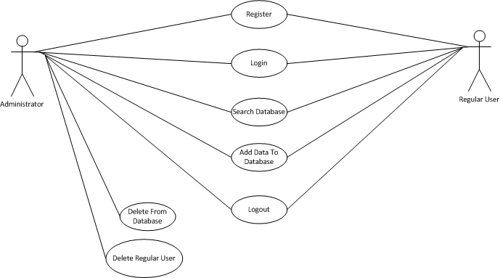

Figure 1: sample use case diagram with explanation

## Extended use cases

Every use case form the list must be elaborated here. E.g

|  |  |  |  |  |
| --- | --- | --- | --- | --- |
| **Use Case ID:** | Enter a unique numeric identifier for the Use Case. e.g. UC-1.2.1 | | | |
| **Use Case Name:** | Enter a short name for the Use Case using an active verb phrase. e.g. Withdraw Cash | | | |
| **Created By:** |  | | **Last Updated By:** |  |
| **Date Created:** |  | | **Last Revision Date:** |  |
| **Actors:** | | [An actor is a person or other entity external to the software system being specified who interacts with the system and performs use cases to accomplish tasks. Different actors often correspond to different user classes, or roles, identified from the customer community that will use the product. Name the actor that will be initiating this use case (primary) and any other actors who will participate in completing the use case (secondary).] | | |
| **Description:** | | [Provide a brief description of the reason for and outcome of this use case.] | | |
| **Trigger:** | | [Identify the event that initiates the use case. This could be an external business event or system event that causes the use case to begin, or it could be the first step in the normal flow.] | | |
| **Preconditions:** | | [List any activities that must take place, or any conditions that must be true, before the use case can be started. Number each pre-condition. e.g.   1. Customer has active deposit account with ATM privileges 2. Customer has an activated ATM card.] | | |
| **Post conditions:** | | [Describe the state of the system at the conclusion of the use case execution. Should include both *minimal guarantees* (what must happen even if the actor’s goal is not achieved) and the *success guarantees* (what happens when the actor’s goal is achieved. Number each post-condition. e.g.   1. Customer receives cash 2. Customer account balance is reduced by the amount of the withdrawal and transaction fees] | | |
| **Normal Flow:** | | [Provide a detailed description of the user actions and system responses that will take place during execution of the use case under **normal, expected** conditions. This dialog sequence will ultimately lead to accomplishing the goal stated in the use case name and description.   1. Customer inserts ATM card 2. Customer enters PIN 3. System prompts customer to enter language performance English or Spanish 4. System validates if customer is in the bank network 5. System prompts user to select transaction type 6. Customer selects Withdrawal From Checking 7. System prompts user to enter withdrawal amount 8. … 9. System ejects ATM card] | | |
| **Alternative Flows:**  **[Alternative Flow 1 – Not in Network]** | | [Document **legitimate** branches from the main flow to handle special conditions (also known as extensions). For each alternative flow reference the branching step number of the normal flow and the condition which must be true in order for this extension to be executed. e.g. Alternative flows in the *Withdraw Cash* transaction:  4a. In step 4 of the normal flow, if the customer is not in the bank network   1. System will prompt customer to accept network fee 2. Customer accepts 3. Use Case resumes on step 5   4b. In step 4 of the normal flow, if the customer is not in the bank network   1. System will prompt customer to accept network fee 2. Customer declines 3. Transaction is terminated 4. Use Case resumes on step 9 of normal flow   Note: Insert a new row for each distinctive alternative flow. ] | | |
| **Exceptions:** | | [Describe any anticipated **error conditions** that could occur during execution of the use case, and define how the system is to respond to those conditions.  e.g. Exceptions to the Withdraw Case transaction  2a. In step 2 of the normal flow, if the customer enters and invalid PIN   1. Transaction is disapproved 2. Message to customer to re-enter PIN 3. Customer enters correct PIN 4. Use Case resumes on step 3 of normal flow] | | |
| **Includes:** | | [List any other use cases that are included (“called”) by this use case. Common functionality that appears in multiple use cases can be split out into a separate use case that is included by the ones that need that common functionality. e.g. steps 1-4 in the normal flow would be required for all types of ATM transactions- a Use Case could be written for these steps and “included” in all ATM Use Cases.] | | |
| **Frequency of Use:** | | [How often will this Use Case be executed. This information is primarily useful for designers. e.g. enter values such as 50 per hour, 200 per day, once a week, once a year, on demand etc.] | | |
| **Special Requirements:** | | [Identify any additional requirements, such as nonfunctional requirements, for the use case that may need to be addressed during design or implementation. These may include performance requirements or other quality attributes.] | | |
| **Assumptions:** | | [List any assumptions that were made in the analysis that led to accepting this use case into the product description and writing the use case description.  e.g. For the *Withdraw Cash* Use Case, an assumption could be:  The Bank Customer understands either English or Spanish language.] | | |
| **Notes and Issues:** | | [List any additional comments about this use case or any remaining open issues or TBDs (To Be Determined) that must be resolved. e.g.   1. What is the maximum size of the that a use can have?] | | |

## User interfaces (mock screens)

Initial mockup screens (even hand drawn drafts) will be inserted here. Each screen will be given an appropriate prototype id.e.g.

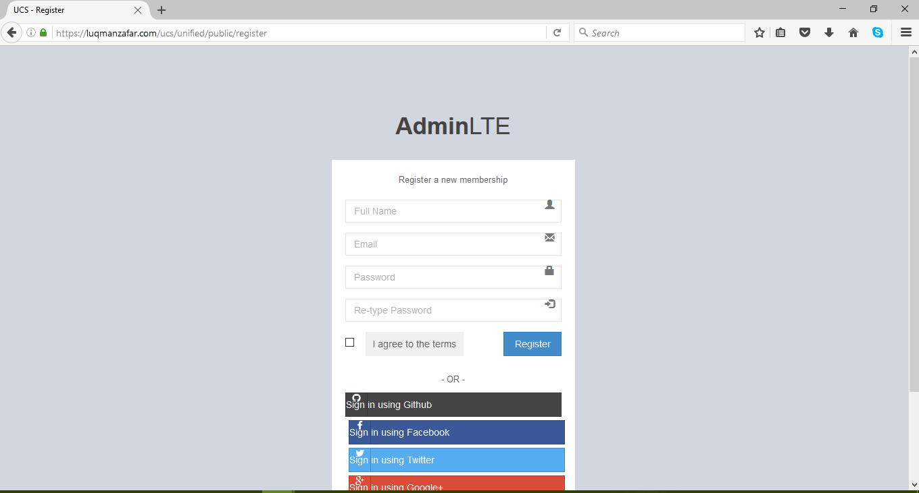

Prototype1: (P1) register a new member

# Data flow diagram (optional)

## Data Flow Diagram Level 0

Identifies sources and sinks only e.g

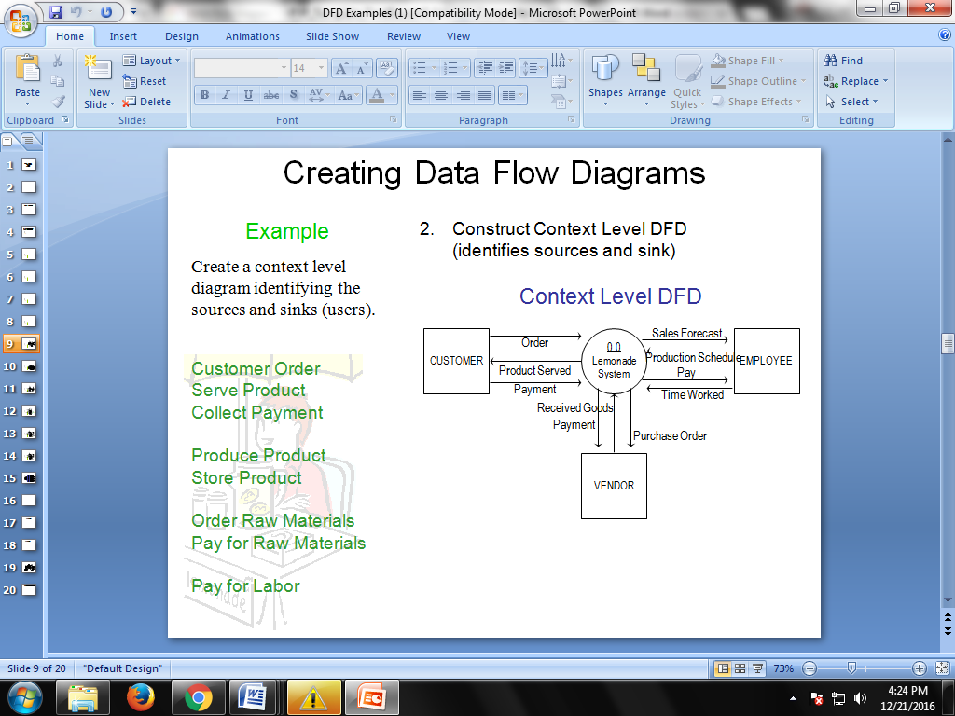

## Data Flow Diagram Level 1

Identifies actual data flows and data storese.g

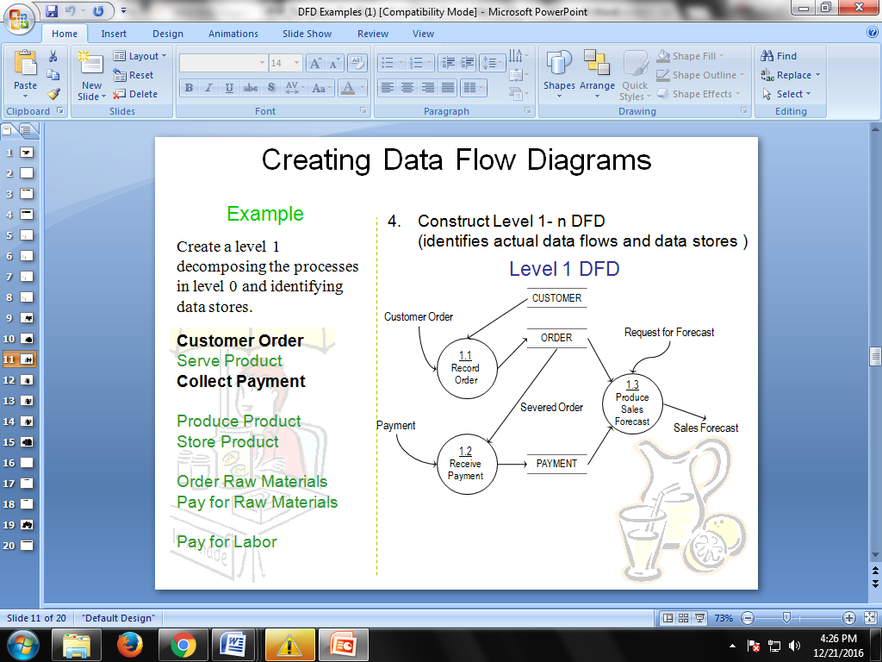

## Data Flow Diagram Level 2

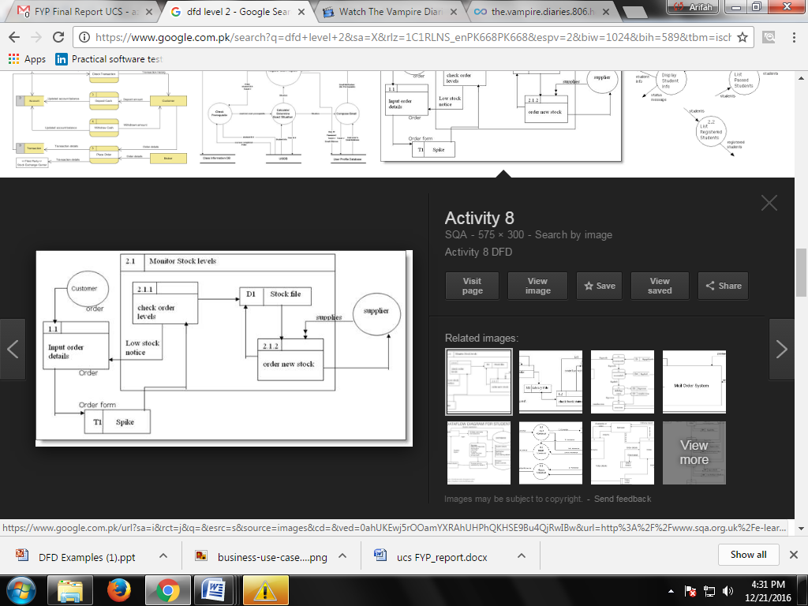

# System Design

Describe the system architecture, or simply provide the architecture diagram. For School system it may include web based front end, webserve , database etc. Don’t worry too much about it just give a simple diagram of a typical web based project.

## System Architecture Diagram



Figure 2: System Architecture

## Class Diagram

## class-example-online-shopping-domain

## Sequence Diagrams

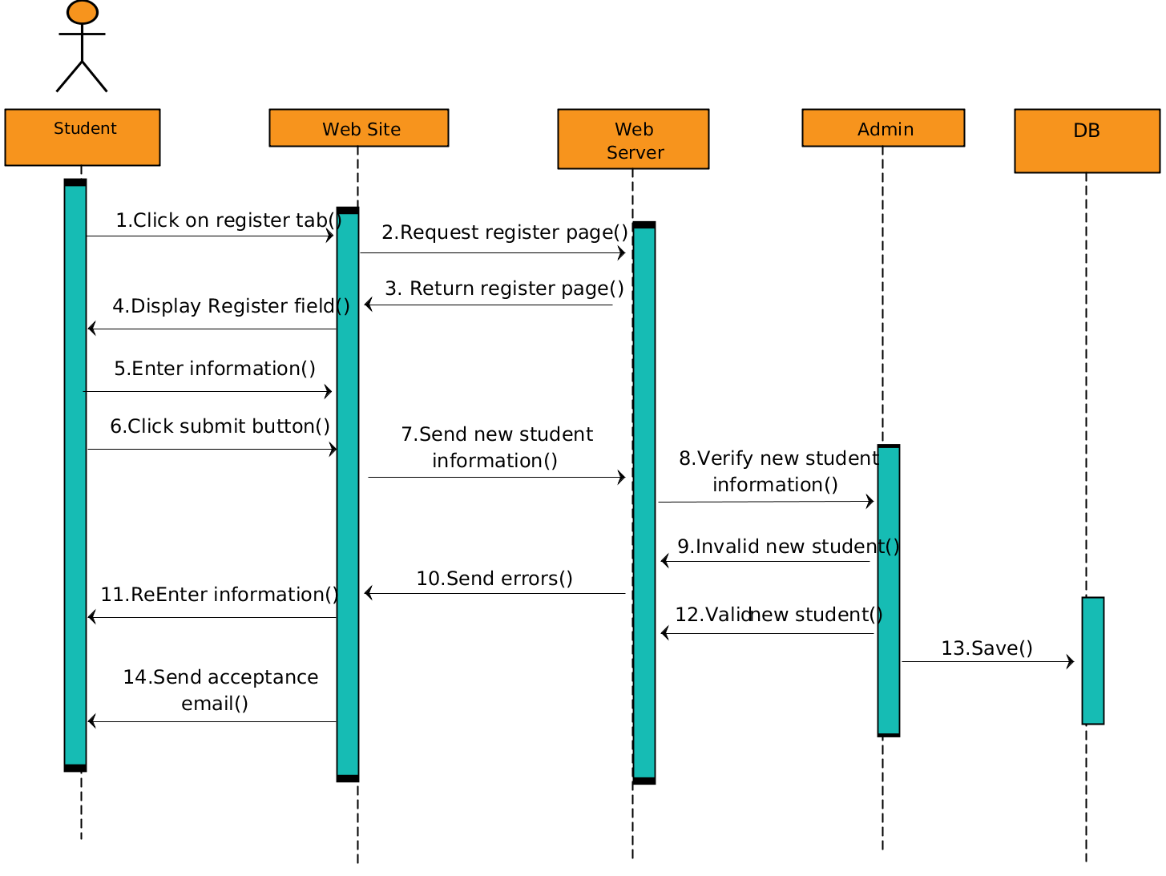

## Collaboration Diagrams

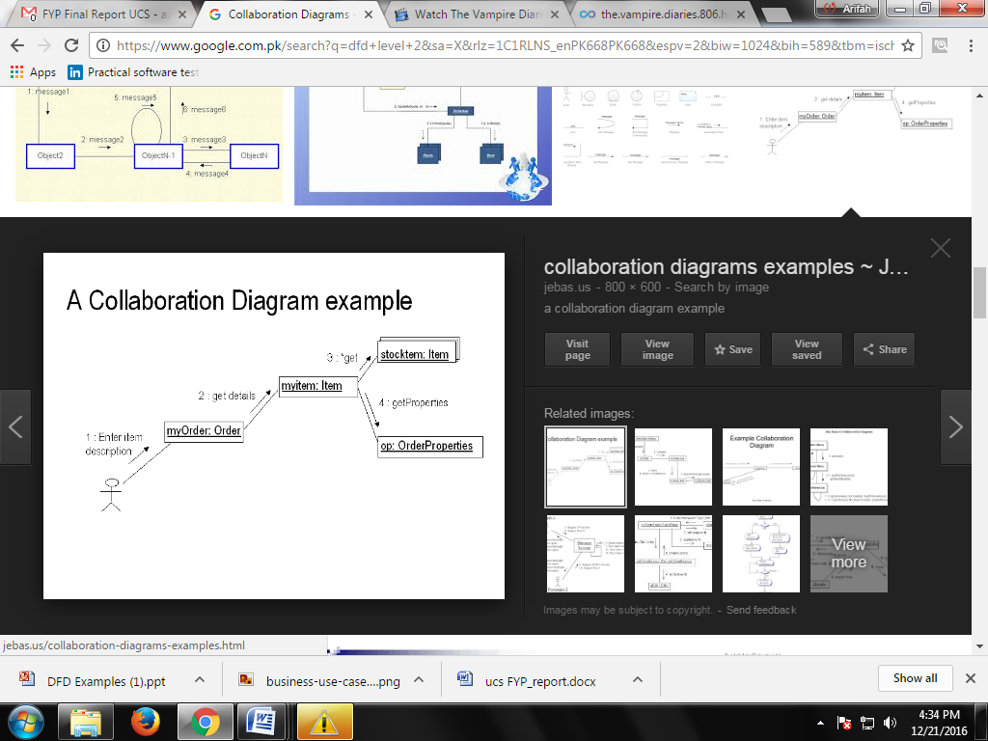

## Other UMLs

This is optional. You may include any other UML to support your system.

## ERD

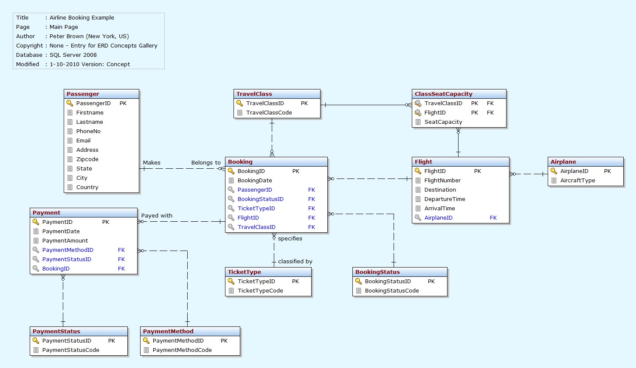

## Data Dictionary

This section may be used to provide the details of interface elements that are present on the screenshots.

|  |  |  |  |  |
| --- | --- | --- | --- | --- |
| Element Name | Type | Validation | Mandatory | Remarks |
|  |  |  |  |  |

# Implementation details

## Development Setup

List your tools and technologies and their role in development.

## Deployment setup

How and where was your software deployed? Did you face any problems, how did you overcome these problems.

## Algorithms

Entire code of software is not required. Just highlight your important (user defined/ improved) algorithms.

## Constraints

### Assumptions

Things we assume will be true.

e.g.:

* *We will receive all necessary technical support from the engineers at cMeRun, Select and Mellon Bank to help design the interfaces between their systems and enGyro.*
* *All database maintenance will be handled by the client.*
* *There will be no real-time interfacing with any accounting systems.*

### System constraints

 A constraint specifies how the system must operate or how it must be built

### Restrictions

Constraints applied on the system by the client

### Limitations

Services your software is unable to provide

# Testing

## Extended Test Cases

## 

## Decision Table

### Code snippet

### Decision coverage table

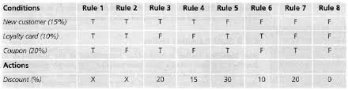

## Traceability Matrix

### RID vs UCID (requirements vs use cases)

|  |  |  |  |  |  |  |  |  |  |  |  |  |  |  |  |  |  |  |  |  |  |
| --- | --- | --- | --- | --- | --- | --- | --- | --- | --- | --- | --- | --- | --- | --- | --- | --- | --- | --- | --- | --- | --- |
| **UCID/RID** | **R**  **1** | **R**  **2** | **R**  **3** | **R**  **4** | **R**  **5** | **R**  **6** | **R**  **7** | **R**  **8** | **R**  **9** | **R**  **10** | **R**  **11** | **R**  **12** | **R**  **13** | **R**  **14** | **R**  **15** | **R**  **16** | **R**  **17** | **R**  **18** | **R**  **19** | **R**  **20** | **R**  **21** |
| UC 1 | ✓ | ✓ |  |  |  |  |  |  |  |  |  |  |  |  |  |  |  |  |  |  |  |
| UC 2 |  | ✓ |  |  |  |  |  |  |  |  |  |  |  |  |  |  |  |  |  |  |  |
| UC 3 | ✓ | ✓ |  |  |  |  |  |  |  |  |  |  | ✓ |  |  |  |  |  |  |  |  |
| UC 4 | ✓ | ✓ |  |  |  |  |  |  |  |  |  |  |  | ✓ |  |  |  |  |  |  |  |
| UC 5 | ✓ | ✓ | ✓ |  | ✓ |  |  |  |  |  |  |  |  |  |  |  |  |  |  |  |  |
| UC 6 | ✓ | ✓ |  | ✓ |  | ✓ |  |  |  |  |  |  |  |  |  |  |  |  |  |  |  |
| UC 7 | ✓ | ✓ | ✓ |  |  |  |  |  | ✓ |  |  |  |  |  |  |  |  |  |  |  |  |
| UC 8 | ✓ | ✓ |  | ✓ |  |  |  |  |  | ✓ |  |  |  |  |  |  |  |  |  |  |  |
| UC 9 | ✓ | ✓ | ✓ |  | ✓ |  |  |  |  |  | ✓ |  |  |  |  |  |  |  |  |  |  |
| UC 10 | ✓ | ✓ |  | ✓ |  | ✓ |  |  |  |  |  | ✓ |  |  |  |  |  |  |  |  |  |
| UC 11 | ✓ | ✓ | ✓ |  | ✓ |  | ✓ |  |  |  |  |  |  |  |  |  |  |  |  |  |  |
| UC 12 | ✓ | ✓ |  | ✓ |  | ✓ |  | ✓ |  |  |  |  |  |  |  |  |  |  |  |  |  |
| UC 19 | ✓ | ✓ | ✓ |  | ✓ |  |  |  |  |  |  |  |  |  | ✓ |  |  |  |  |  |  |
| UC 20 | ✓ | ✓ |  | ✓ |  | ✓ |  |  |  |  |  |  |  |  |  | ✓ |  |  |  |  |  |
| UC 21 | ✓ | ✓ | ✓ |  |  |  |  |  |  |  |  |  |  |  |  |  |  |  |  |  |  |
| UC 22 | ✓ | ✓ |  | ✓ |  |  |  |  |  |  |  |  |  |  |  |  |  |  |  |  |  |
| UC 23 | ✓ | ✓ | ✓ |  |  |  |  |  |  |  |  |  |  |  |  |  | ✓ |  |  |  |  |
| UC 24 | ✓ | ✓ |  | ✓ |  |  |  |  |  |  |  |  |  |  |  |  |  | ✓ |  |  |  |
| UC 25 | ✓ | ✓ | ✓ | ✓ |  |  |  |  |  |  |  |  |  |  |  |  |  |  | ✓ |  |  |
| UC 26 | ✓ | ✓ | ✓ | ✓ |  |  |  |  |  |  |  |  |  |  |  |  |  |  |  | ✓ |  |
| UC 27 | ✓ | ✓ | ✓ | ✓ |  |  |  |  |  |  |  |  |  |  |  |  |  |  |  |  | ✓ |

### Prototypes (RID vs PID)

### Test Cases (RID vs TID)

### Coverage (UCID vs TID)

# Results/Output/Statistics

## %completion

Use the matrix & values from 7.3.1 to show that all requirements are being fulfilled.

## %accuracy

Use the matrix & values from 7.3.3 to show that all requirements have been implemented correctly.

## %correctness

Use the matrix & values from 7.3.4 to show that all requirements have been tested to be conforming to requirements.

# Conclusion

# Future work

# Bibliography

Use IEEE or ACM format for citations

## Books

## Journals

## Articles

## Research papers

## Other References

# Appendix

## Glossary of terms

## Pre-requisites

Must use contents of development/ deployment setup & external system dependencies